St Leo’s Bulletin 5 Beech Avenue, G41 5BY.2nd Sunday of Lent
Sunday vigil: Saturday at 6.00p.m. Sunday 10.30 a.m.
Weekday Mass 10.00 Confessions Saturday at 5.30 p.m. & on request.
Sally Lowe died the other day. Her funeral Mass will be celebrated in St Leo’s at 10.00 on March 10th


Entry:
The Father’s voice was heard from the cloud:
This is my Son, the Beloved. Listen to him. Listen to him.
Glory to the Father, glory to the Son,
glory to the Holy Spirit now and for ever. Amen.
The Father’s voice was heard from the cloud:
This is my Son, the Beloved. Listen to him. Listen to him.

Penitential Rite: Kyrie, eleison. . . . . . . .

The Liturgy of the Word
First reading | Genesis 12:1-4a

The call of Abram, the father of the People of God.
In those days: The Lord said to Abram, ‘Go from your country and your kindred and your father’s house to the land that I will show you. And I will make of you a great nation, and I will bless you and make your name great, so that you will be a blessing. I will bless those who bless you, and him who dishonours you I will curse, and in you all the families of the earth shall be blessed.’ So Abram went, as the Lord had told him.
The Word of the Lord: Thanks be to God.

Psalm 32: He fills the earth with his love.

The word of the Lord is faithful, we trust him in all he does.
The Lord loves justice, justice and fairness, he fills the earth, he fills the earth, he fills the earth with his love.
He fills the earth with his love.

By his word the heav'ns were made;
the breath of his mouth made the stars.
The Lord looks on those, those who revere him, on those who hope, on those who hope, on those who hope in his love. He fills the earth with his love.

And so we await the Lord, the Lord is our help and shield.
We trust that your love will be upon us, we place all our hope, we place all our hope, we place all our hope in you.
He fills the earth with his love.

Second reading 2 Timothy 1 : 8b - 10
Beloved: We share in suffering for the gospel by the power of God, who saved us and called us to a holy calling not because of our works, but because of his own purpose and grace, which he gave us in Christ Jesus before the ages began, and which now has been manifested through the appearing of our Saviour Christ Jesus, who abolished death and brought life and immortality to light through the gospel.
The word of the Lord: Thanks be to God.

To welcome the Gospel
Praise to you, O Christ, King of eternal glory.
Praise to you, O Christ, King of eternal glory.
The Father’s voice was heard from the cloud:
This is my Son, the Beloved. Listen to him. Listen to him.
Praise to you, O Christ, King of eternal glory.
Praise to you, O Christ, King of eternal glory.

A reading from the holy Gospel according to Matthew 17: 1 - 9

‘His face shone like the sun.’
At that time: Jesus took with him Peter and James and John his brother, and led them up a high mountain by themselves. And he was transfigured before them, and his face shone like the sun, and his clothes became white as light. And behold, there appeared to them Moses and Elijah, talking with him. And Peter said to Jesus, ‘Lord, it is good that we are here. If you wish, I will make three tents here, one for you and one for Moses and one for Elijah.’ He was still speaking when, behold, a bright cloud overshadowed them, and a voice from the cloud said, ‘This is my beloved Son, with whom I am well pleased; listen to him.’ When the disciples heard this, they fell on their faces and were terrified. But Jesus came and touched them, saying, ‘Rise, and have no fear.’ And when they lifted up their eyes, they saw no one, but Jesus only. And as they were coming down the mountain, Jesus commanded them, ‘Tell no one the vision, until the Son of Man is raised from the dead.’
The Gospel of the Lord: Praise to you, Lord Jesus Christ

Homily

The Nicene Creed
I believe in one God, the Father almighty,
maker of heaven and earth, of all things visible and invisible.
I believe in one Lord Jesus Christ,
the Only Begotten Son of God,
born of the Father before all ages.
God from God, Light from Light, true God from true God,
begotten, not made, consubstantial with the Father;
through him all things were made.
For us men and for our salvation he came down from heaven,
and by the Holy Spirit was incarnate of the Virgin Mary,
and became man.
For our sake he was crucified under Pontius Pilate,
he suffered death and was buried,
and rose again on the third day in accordance with the Scriptures.
He ascended into heaven
and is seated at the right hand of the Father.
He will come again in glory to judge the living and the dead
and his kingdom will have no end.
I believe in the Holy Spirit, the Lord, the giver of life,
who proceeds from the Father and the Son,
who with the Father and the Son is adored and glorified,
who has spoken through the prophets.
I believe in one, holy, catholic and apostolic Church.
I confess one Baptism for the forgiveness of sins
and i look forward to the resurrection of the dead
and the life of the world to come. Amen.
Intercessions
During the Preparation of the Gifts

You must love the Lord our God with all your heart and soul;
you must love the Lord your God with all your mind & strength;
and you must love your neighbour as you love yourself;
You must love the Lord our God with heart and soul and mind and strength and your neighbour as yourself.

Bellahouston Sanctus

Memorial We proclaim your death, O Lord, and profess your resurrection until you come, until you come,
until you come again.

Bellahouston Lamb of God

Communion

As we eat this bread and drink this cup
though many we are one:
one bread, one cup, one faith, one church,
one Lord for ever more. (2)

Hymn

The love I have for you, my Lord,
is only a shadow of your love for me;
only a shadow of your love for me,
your deep abiding love.

My own belief in you, my Lord,
is only a shadow of your faith in me,
only a shadow of your faith in me, your deep and lasting faith.

My life is in your hands, my life is in your hands.
My love for you will grow, my God, your light in me will shine.

The dream I have today, my Lord,
is only a shadow of your dreams for me,
only a shadow of all that will be if I but follow you.

The joy I feel today, my Lord,
is only a shadow of your joys for me,
only a shadow of your joys for me, when we meet face to face.

After Mass: In the name of the Father and of the Son
and of the Holy Spirit now and for ever. Amen.

Copyright:. The Father’s Voice; Ps 32: Words taken from The Psalms : A New Translation published by William Collins & Co Ltd © The Grail. Music : St Mungo Music © Kevin Mayhew. Book graphic © Netta Ewing. Words and music reproduced with the One License A-633262 and CCLI74396
Fr Gerard Mitchell the Jesuit Community and
Glasgow Churches Together Invite You to an
Ecumenical Evening Prayer

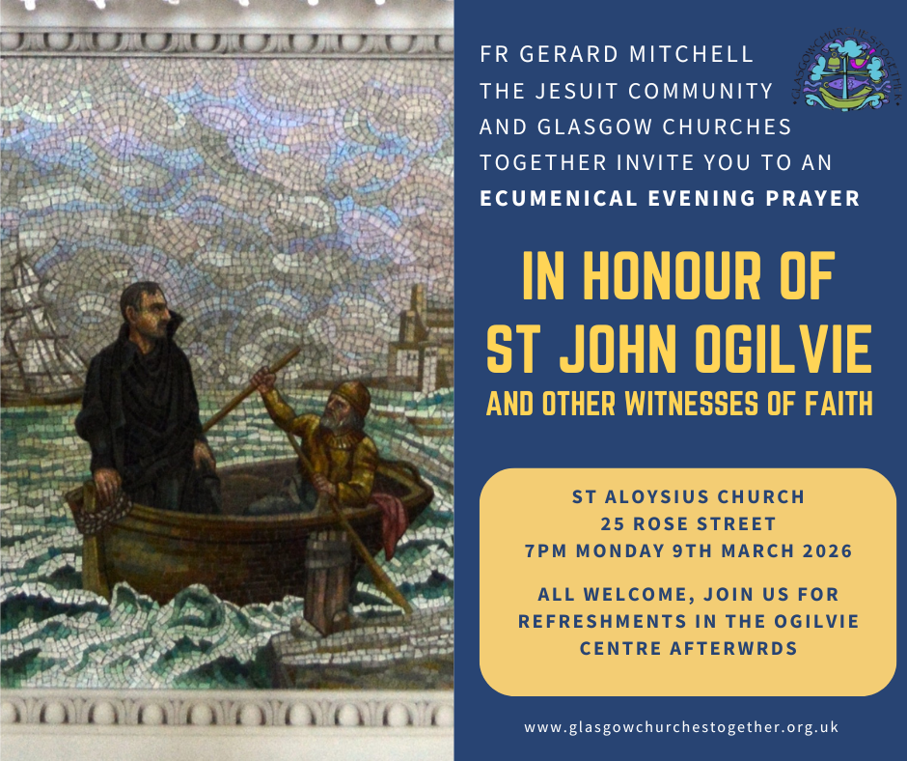

St Aloysius Church

25 Rose Street

7pm Monday 9th March 2026

With Church and Civic Leaders,
The St Mungo Singers, and Musicians

Radioalba.org

7.00 – 8.00 repeated hourly till 12.00
7.00 Morning Prayers for Lent
7.15 Morning Prayers with school for Lent
07.20: Canon Bob Hill looks ahead at the Gospel of John and the woman at the well
Margaret Chapman introduces the daily readings at Mass.
7.25: rhapsody the basis of our faith and confession
7.30: In our Magazine: In our Magazine this week Fr Tom Magill reflects on the 'temptations of Christ'; The Scottish Bishops on Religious Education; more settler attacks in the West Bank; Madagascar; Chicago's Ash Wednesday; Archbishop Moth of Westminster. and "The Father's Voice
12.00/6.00 In our Glasgow Churches Together service we mark the 2nd Sunday of Lent
12.15/6.15: Our Lenten Sunday reading with Ps 90 and passages from Exodus 13 and 14 and from a sermon pf St Leo the Great
012.30/6.30: Newsnatter from Elizabeth Adam and Wilson Bain beginning with a birthday celebration, the 8th centenary of St Francis, the purview communion and the status of Greenland, Fiji and lots more.
01.00/7.00: In our Glasgow Churches Together service we mark the 2nd Sunday of Lent
01.15/7.15: 12.15: Our Lenten Sunday reading with Ps 90 and passages from Exodus 13 and 14 and a sermon of St Leo the Great
1.30/7.30: Newsnatter from Elizabeth Adam and Wilson Bain beginning with a birthday celebration, the 8th centenary of St Francis, the purview communion and the status of Greenland, Fiji and lots more.

2.00 - 6.00: Music

8.00: Vespers of Lent
8.20: Magazine
8.50 Night Prayer
‘Thank you’ to the people so far who have volunteered to serve the parish in the ministries suggested below. If you also would like to share in parish life in any special way please put your name and contact details on the sheets in the porch.

Lent opportunities

This year marks the 8th centenary of St Francis of Assisi - Pope Leo asks us to make this a year of peace - let’s pray for peace at our daily morning prayers.

Monday, Wednesday and Friday:
10 am short Morning Prayer with Mass
Tuesday and Saturday
10 am short Stations of the Cross with Mass except on Tuesday 17th March, St Patrick’s Day, when we will have a special Mass without Stations

Wednesday 18th March: we will celebrate the Vigil of St Joseph’s Day (Feast the 19th) on the Wednesday morning.

Thursday
Ecumenical Morning Prayer for Lent
10 am St Leo’s 19th February and 12th March
10 am Ibrox Parish Church 26th February and 19th March
10 am Sherbrooke Mosspark 5th March and 26th March

Ecumenical Passover on Thursday 26th March at 7 pm

Parish Penance Service 7 pm Monday 30th March
Ecumenical Holy Week Service with Ibrox and Sherbrooke Mosspark in St Leo’s 7 pm Wednesday

Radioalba.org also contains Morning Prayers and Stations for Lent

There will be a series of 4 talks at Christ the King parish on Feb 26, March 12, 19 & 26 and based on the Sunday Gospel readings at 7 pm

GROW IN FAITH GROUP
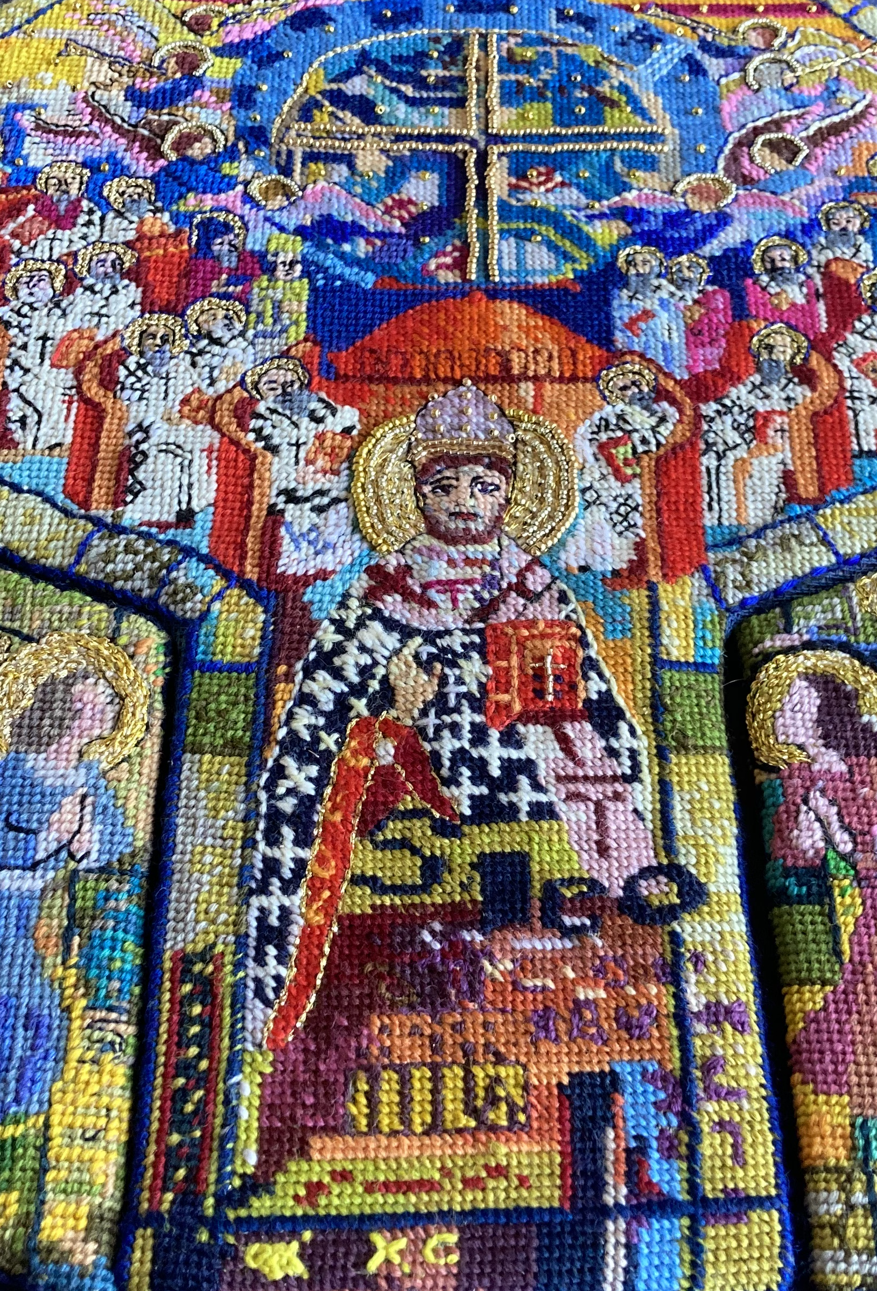

Thursday meetings in the warmth of the parish house at 7 pm:

March 5th: inspiration from the BBC film on Julian of Norwich
March 19: Scott Hahn’s introduction to ‘The Seven Last Words’
March 26: Annual Ecumenical Passover
April 2: 7 pm Mass of the Lord's Supper
9 pm Short Night Prayer
April 16: Social Evening to plan the Easter – Summer session

Can you gift aid?
This is an appeal not only to those new to the parish but also to those of our longer established parishioners who have not yet joined our Gift Aid Scheme.
The Gift Aid scheme enables the parish to claim back tax from HMRC on your donations at no cost to yourself - and for higher tax rate payers, gives them some benefit. All you need to do is sign a declaration form in favour of the parish and either pay through use of our parish gift aid envelopes or bank transfer.
If you would like to help us get more income at no cost, speak either to Fr Gerry or to Grace Buckley. All information is held confidentially.
--------------------------------------

Sciaf

The walking group are hoping to support SCIAF ‘s Walk for Water Campaign.

There are two walks planned for March. It has been suggested that anyone taking part in either walk make a donation which will be forwarded to SCIAF. If you would like to join us either by walking or donating.

Dates are 10th March walking Greenock Cut (10 km), 21 st March Palacerigg & Fannyside Loch (approx 5 km).
Please speak to Robert Carachi or Eamon Murtagh for more details .

------------------------------------------
Ps 32 with Commentary by Dr Noel Donnelly
The whole of Psalm 32 is a great joyful song of thanks for the gift of creation. The selected verses for this weekend’s liturgy concentrate on the love of God in all of this wonderful creative act. But this love may now seem hidden behind the trials that are now afflicting the community in its experiences of famine and the threatening circumstances of imminent death. The hearers are encouraged to look around in hope for signs of God’s faithful love to rescue them and keep them all alive. The psalmist is certain of the coming of God’s saving actions as he or she waits and exclaims, “The Lord is our help and our shield!” This cry is taken up by the congregation as it waits: “May your love be upon us O Lord!”
This follows the first reading from Isaiah, the fourth of the Suffering Servant Songs in Isaiah. We don’t know who this person was; perhaps the prophet who had given his life for the people, or even it refers to the suffering people of Israel in holding on to the faith in their exile in Babylon. The psalmist honours the struggles of the ancestors, as we may do in honouring the faith of our fathers and mothers before us.
The hymn ends in 20-22 with renewed hope in the faithful ongoing love of the Lord: “May your love be upon us O Lord, as we place all our hope in you!”.
On the 29th Sunday of Year B our psalm leads forward in this same theme as it speaks in Mark about Jesus, the Son of Man who came to serve and give his life as a ransom for many. Jesus adds for us too, “Anyone who wants to be first among you must be a slave to all, for the Son of Man did not come to be served but to serve and give his life as a ransom for many”
The psalmist encourages us surely to wait for the Lord’s return, but in the meantime to do so remembering that “the Lord is our help and our shield!”
The full psalm starts with an instruction for the singers: they are encouraged to play skilfully and to remember they are playing “for the Lord” and not for their own satisfaction. “Give thanks to the Lord upon the harp; with ten-stringed lute sing God’s praises. Sing and play loudly with all your skill! We might remember the zeal of Louis Armstrong as he sang, “What a wonderful world!”
Our psalm concludes with a prayer for hope: “May your love be upon us O Lord, as we place all our hope in you!”. With this love may you love long and prosper!

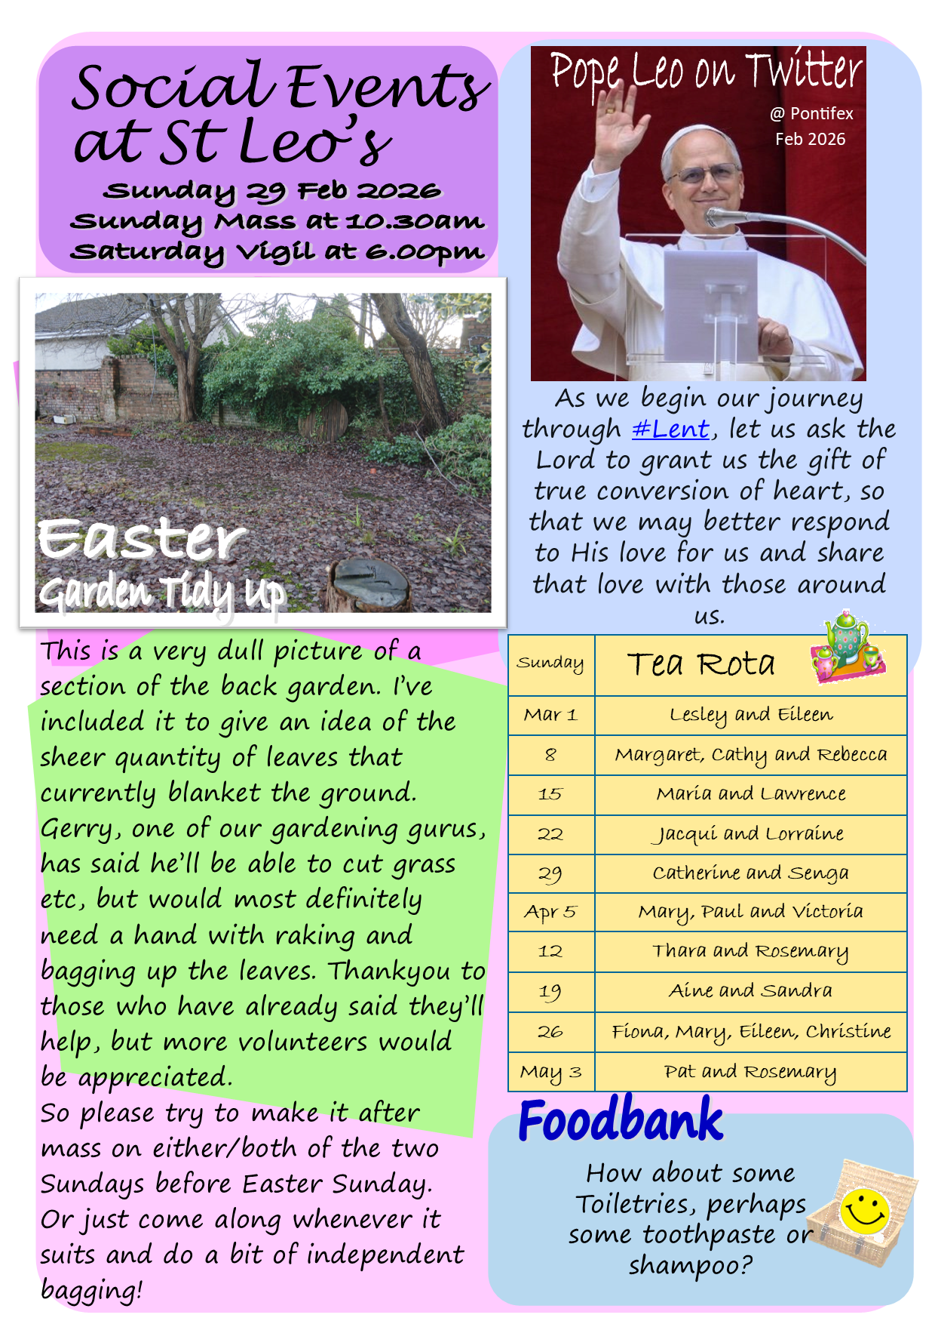

Intercessions March 1st

Let’s pray that we may be able to keep our Lenten intentions in prayer, goodness to others and self-sacrifice
Lord, hear us: Lord, graciously hear us.

Let’s continue to pray for peace in the Middle East including Iran, the Holy Land, Gaza, Ukraine, Venezuela and throughout the world. Lord, hear us: . . . . .

Let’s pray for those who are ill: including Fr Pat Currie, Brenda Coplair, Paul McKeown, Fr Bob McCann, Kathleen Mallon, Joseph Chambers, Ellen Hamilton, Francis McColl, Clark Dunlop, Kirsty Macdonald, Eileen McLean, Caroline Mills, Yvonne Watt and Maureen McKean. Lord, hear us: . . . . . .

Let’s pray for our deceased sisters and brothers including: Brian Quail, John Spiers, Dom Coia, Mary Frances McCaughley, Anne Davie, Connie Ness, Canon Bob Spence, John Deans, Fr Tommy Hendry, Joe McKee, Michael McCarney, Tommy Byrne, and Brian Shields,

And, for those whose anniversaries fall about now, including Anne Byrne, Isa Greene, Josephine Smith, May Scott, Ellen Cairns, Norah Ritchie, Gerald Barry, James McGarry, Nancy Barrett, Joe McAuley, Margaret Lanigan, Willie Raworth, Anne Mellon. James McKeown, Sarah McKeown. Lord, hear us . . . . . . . .

